Linux Fundamentals & Administration

Course: Linux System Administration
Prepared By: Saiyam Goyal
Platform: Ubuntu Linux (QEMU Virtual Machine)
Submission Date: July 2026

Table of Contents
Introduction 3
Objectives 4
Tools & Environment 4
Phase 1 - Linux File System Basics 5
Objective 5
Commands Used 5
Practical Activities Performed 6
Key Learning 9
Challenges Faced 9
Outcome 9
PHASE 2 - FILE PERMISSIONS & FILE EDITING 10
Objective 10
Commands Used 10
Practical Activities Performed 11
Step 11: Displayed End of the File 14
Key Concepts Learned 15
Skills Demonstrated 15
Outcome 15
PHASE 3 - USER & GROUP MANAGEMENT 16
Objective 16
Commands Used 16
Practical Activities Performed 17
Key Concepts Learned 20
Skills Demonstrated 20
Outcome 20
PHASE 4 - PROCESS MANAGEMENT 21
Objective 21
Commands Used 21
Practical Activities Performed 22
Key Concepts Learned 27
Skills Demonstrated 27
Outcome 27

Introduction
Linux is a powerful, open-source operating system widely used across servers, cloud platforms, enterprise networks, embedded systems, and cybersecurity environments. Due to its stability, security, flexibility, and performance, Linux has become one of the most trusted operating systems for managing critical IT infrastructure.
Linux plays a significant role in modern technology. Most web servers, cloud computing platforms, virtualisation environments, and enterprise applications are built on Linux-based systems. Major cloud service providers such as Amazon Web Services (AWS), Microsoft Azure, and Google Cloud Platform (GCP) extensively use Linux as their primary operating system.
Linux administration skills are highly valuable for professionals working in Information Technology, Cloud Computing, Cybersecurity, DevOps, System Administration, and Technical Support. A Linux administrator is responsible for managing users, configuring permissions, monitoring system performance, maintaining system security, troubleshooting issues, and ensuring the reliable operation of Linux-based systems.
The primary purpose of this project was to gain practical, hands-on experience with essential Linux administration tasks using Ubuntu Linux. Throughout this project, various command-line operations were performed, including file and directory management, file permissions, user and group administration, process management, and system monitoring. The project was designed to strengthen practical Linux skills and build a solid foundation for real-world system administration and technical support roles.
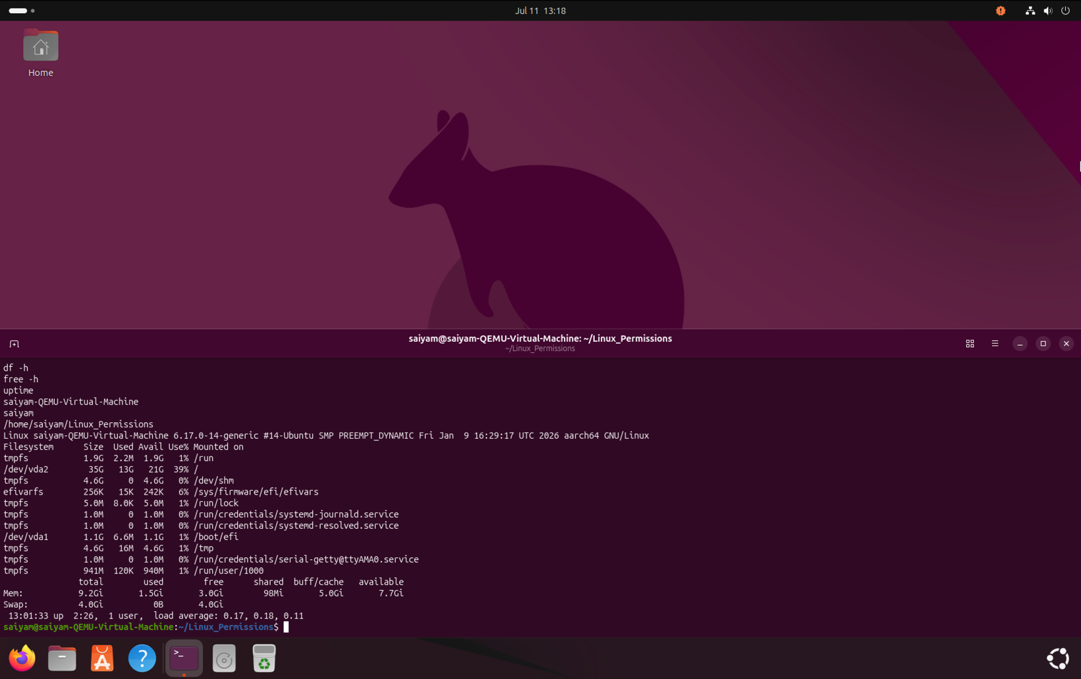
Figure 1 : Ubuntu Linux environment used for performing Linux administration tasks.

Objectives
The primary objective of this Linux practical training was to develop a strong foundation in Linux system administration through hands-on experience. The activities were designed to enhance proficiency in using the Linux command-line interface, understanding the Linux file system and directory structure, and managing file permissions and ownership. The practical sessions also focused on creating and administering user accounts and groups, monitoring and controlling system processes, and analysing disk usage and overall system resources. By completing these exercises, practical skills in Linux administration, troubleshooting, and efficient command-line operations were developed, providing a solid foundation for working in Linux-based environments.

Tools & Environment

The practical activities were carried out in a Linux-based environment using Ubuntu Linux as the operating system. Virtualisation was implemented through QEMU, providing an isolated and efficient platform for performing Linux administration tasks. All commands and system operations were executed using the Bash terminal, enabling hands-on experience with Linux command-line utilities. The project was systematically organised into five progressive phases—Phase 1, Phase 2, Phase 3, Phase 4, and Phase 5—with each phase focusing on different aspects of Linux administration, allowing knowledge and practical skills to be developed in a structured and comprehensive manner.

Phase 1 - Linux File System Basics

Objective
The objective of this phase was to understand the basic Linux file system and practice essential file and directory management commands. This phase focused on navigating directories, creating files and folders, copying, moving, renaming, and deleting files using the Linux command line.

Commands Used
pwd | Display current working directory
ls | List files and directories
cd | Change directory
mkdir | Create a directory
touch | Create a file
cp | Copy files
mv | Move or rename files
rm | Delete files
rmdir | Remove empty directories

Practical Activities Performed

Step 1 – Verified Current Working Directory

Figure 2: Used the pwd command to identify the current working directory.

Step 2 – Listed Home Directory Contents
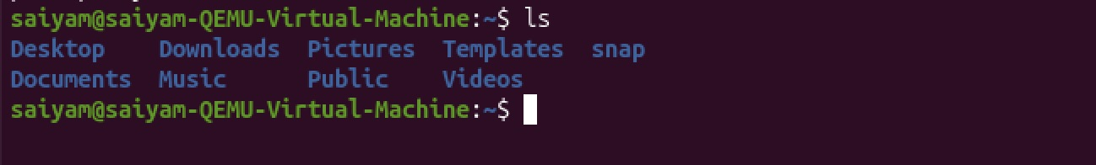
Figure 3: Used the ls command to display all files and folders available inside the home directory.

Step 3 – Displayed Hidden Files
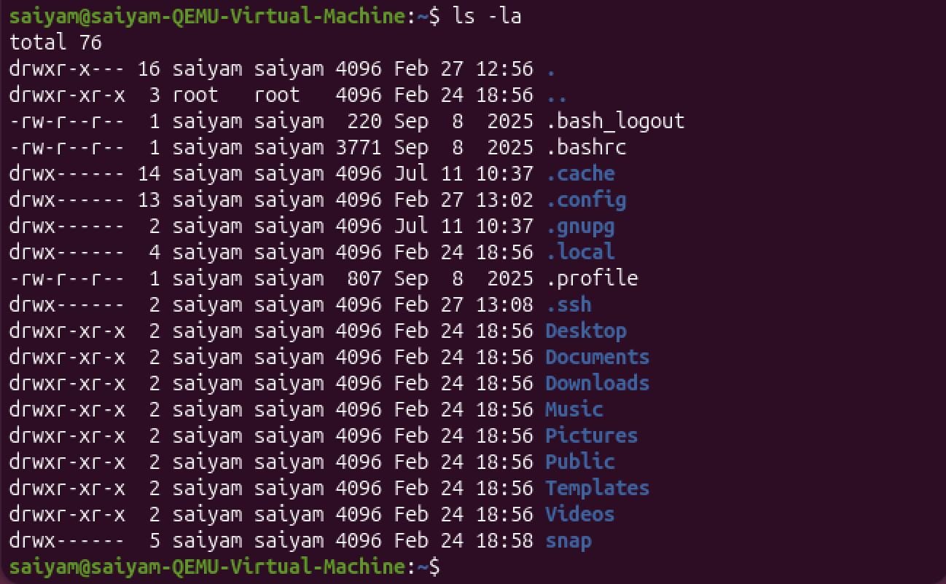
Figure 4: Executed the ls -la command to view hidden files along with detailed file permissions and ownership information.

Step 4 – Verified Project Directory

Figure 5: Confirmed that the Linux_Practice directory existed inside the home directory.

Step 5 – Navigated to Project Directory

Figure 6: Changed the current working directory to Linux_Practice and verified the location using pwd.

Step 6 – Created a New File

Figure 7: Created a new text file named notes.txt using the touch command and verified its creation.

Step 7 – Copied a File
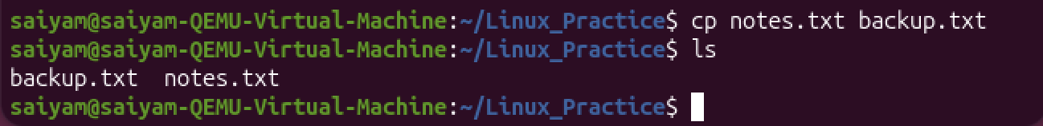
Figure 8: Created a duplicate of notes.txt named backup.txt using the cp command.
Step 8 – Renamed a File
Figure 9: Renamed backup.txt to renamed.txt using the mv command.

Step 9 – Deleted a File
Figure 10: Removed renamed.txt using the rm command.

Step 10 – Removed the Directory
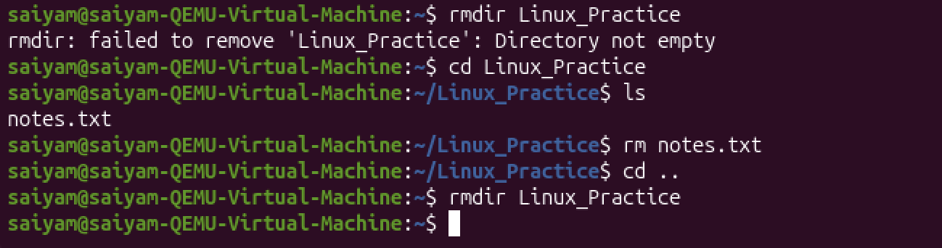
Figure 11: Initially attempted to remove the Linux_Practice directory using rmdir, but the operation failed because the directory still contained notes.txt. After deleting the remaining file, the directory was successfully removed using rmdir.

Key Learning
During this practical session, I learned the fundamentals of Linux directory navigation and practised creating, renaming, copying, and deleting files using terminal commands. I also gained an understanding of how Linux handles non-empty directories and the appropriate methods for managing them. Overall, the session improved my confidence in using the Linux terminal and performing essential file and directory management tasks efficiently.

Challenges Faced
While removing the directory using rmdir, an error occurred because the directory still contained files. After understanding that rmdir only removes empty directories, I deleted the remaining files and successfully removed the directory.

Outcome
Successfully completed all basic Linux file system operations, including directory navigation, file creation, copying, renaming, deletion, and directory management. This phase established a strong foundation for advanced Linux administration tasks.

PHASE 2 - FILE PERMISSIONS & FILE EDITING

Objective
The objective of this phase was to understand Linux file permissions, ownership, user identification, text file editing, and basic file content management using commonly used Linux commands. This phase also introduced the Linux permission model and file inspection utilities used by system administrators.

Commands Used
ls -l | Displays files and directories in long listing format, including file permissions, ownership, file size, and last modification date.
chmod | Changes the permissions (Read, Write, Execute) of files and directories for the owner, group, or others.
whoami | Displays the username of the currently logged-in user.
id | Shows detailed information about the current or specified user, including User ID (UID), Group ID (GID), and group memberships.
groups | Displays all Linux groups to which the current or specified user belongs.
nano | A terminal-based text editor used to create and edit text files directly from the command line.
cat | Displays the complete contents of a file in the terminal. It can also be used to combine multiple files.
head | Displays the first 10 lines of a file by default. Useful for quickly viewing the beginning of large files.
tail | Displays the last 10 lines of a file by default. Commonly used to monitor log files and view recent entries.

Practical Activities Performed

Step 1: Created the Working Directory
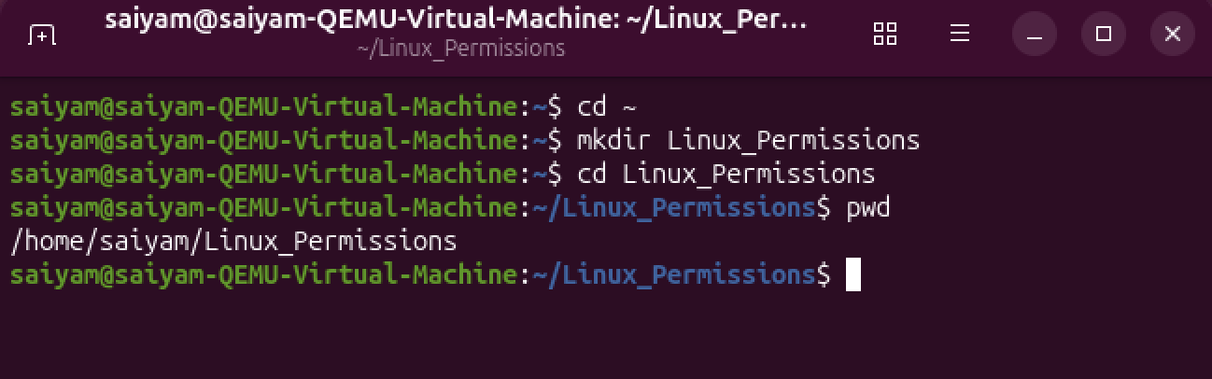
Figure 12: Created a dedicated project directory named Linux_Permissions, navigated into it, and verified the current working directory using the pwd command.

Step 2: Created Practice Files
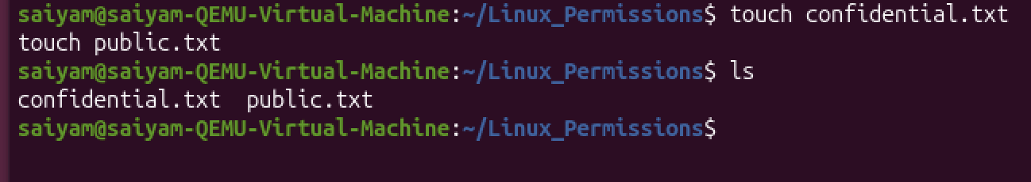
Figure 13: Created two files named confidential.txt and public.txt to demonstrate Linux file permission management and verified their creation using the ls command.

Step 3: Verified Default File Permissions
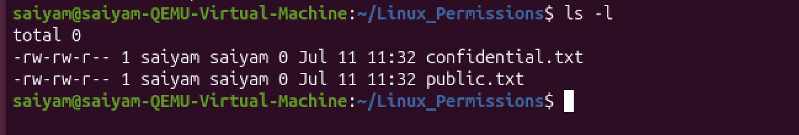
Figure 14: Displayed the default permissions assigned to both files using the ls -l command before making any permission changes.

Step 4: Modified File Permissions
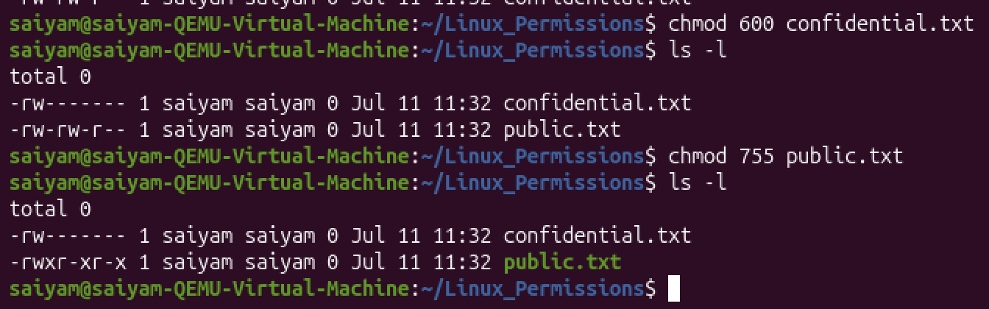
Figure 15: Applied custom permissions using the chmod command

Step 5: Verified Current User
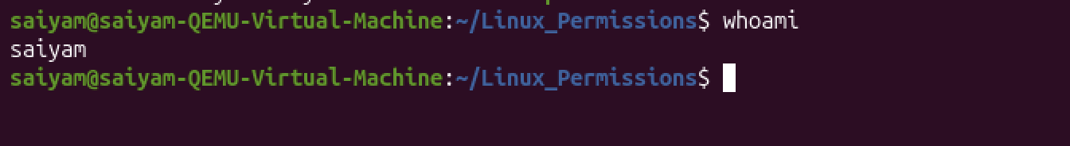
Figure 16: Verified the identity of the currently logged-in user using the whoami command.

Step 6: Displayed User Information
Figure 17: Displayed the current user's UID, GID, and supplementary group memberships using the id command.

Step 7: Verified Group Membership
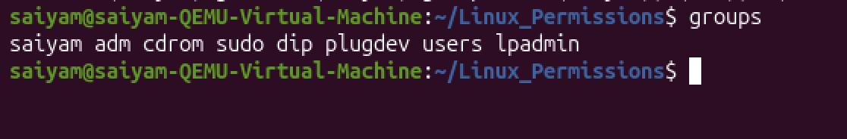
Figure 18: Displayed all groups associated with the current user using the groups command.
Step 8: Edited the File Using Nano
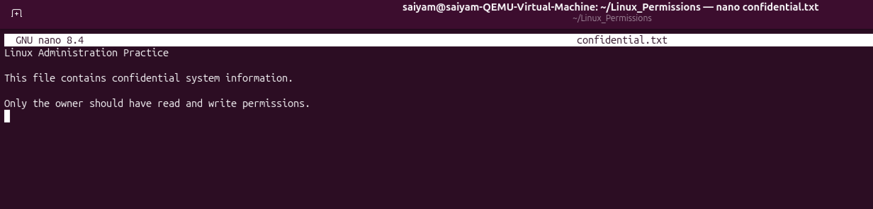
Figure 19: Opened confidential.txt using the Nano text editor and added sample confidential system information.

Step 9: Displayed Complete File Contents
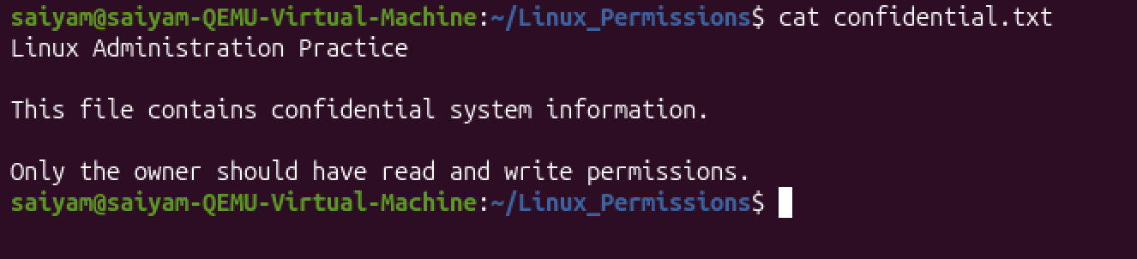
Figure 20: Verified the saved contents of confidential.txt using the cat command.

Step 10: Displayed Beginning of the File
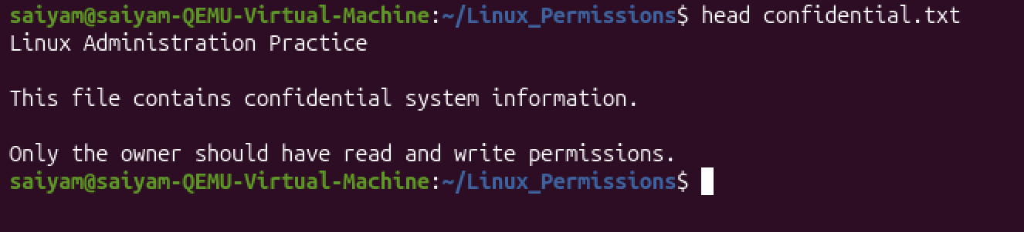
Figure 21: Displayed the first portion of the file using the head command.

Step 11: Displayed End of the File
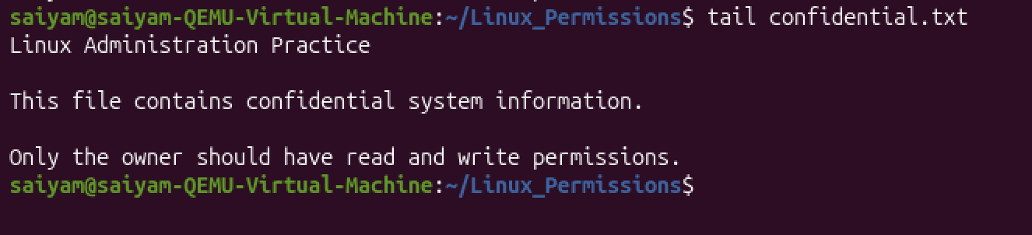
Figure 22: Displayed the last portion of the file using the tail command.

Step 12: Final Verification
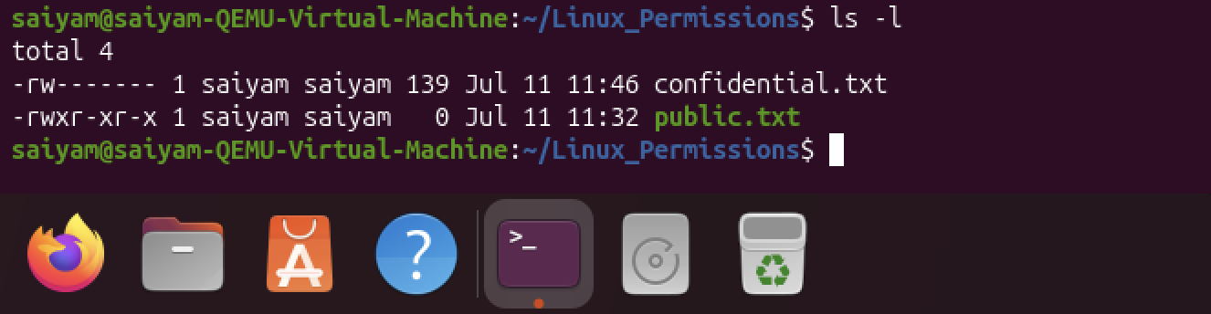
Figure 23: Performed a final verification of the file permissions after editing the file to ensure that the configured permissions remained unchanged and the file size reflected the newly added content.

Key Concepts Learned
During this practical session, I gained a solid understanding of Linux file permissions and the significance of read, write, and execute permissions in controlling access to files and directories. I learned how to modify permissions using the chmod command and understood the concepts of file ownership, user identification, and group membership in the Linux operating system. Additionally, I developed skills in terminal-based text editing using Nano, inspecting file contents through various command-line utilities, and understanding the Linux permission security model, which helps ensure secure and controlled access to system resources.

Skills Demonstrated
During this practical session, I learned how to view and understand file permissions in Linux and modify them using the chmod command. I explored how to identify the current user information and check the groups associated with a user to better understand user management and access control. I also practised editing text files using the Nano text editor, viewing complete file contents with the cat command, and reading specific portions of files using the head and tail commands. Additionally, I gained an understanding of Linux file security concepts, including how permissions help protect files and control user access within the operating system.

Outcome
Successfully completed practical exercises on Linux file permissions and text file management. The activities included verifying default permissions, modifying access rights, identifying user and group information, editing files using Nano, and inspecting file contents using Linux command-line utilities. This phase provided hands-on experience with one of the most important responsibilities of a Linux System Administrator—managing secure file access and efficiently working with files from the terminal.

PHASE 3 - USER & GROUP MANAGEMENT

Objective
The objective of this phase was to learn Linux user and group administration by creating users and groups, assigning passwords, managing group memberships, verifying user information, and testing user login. This phase helped in understanding how Linux manages user accounts, permissions, and authentication.

Commands Used

cat /etc/passwd | Displays all user accounts available in the system.
tail | Displays the last few lines of a file.
groupadd | Creates a new Linux group.
grep | Searches for specific text inside a file.
useradd | Creates a new user account.
passwd | Sets or changes a user's password.
id | Displays UID, GID, and group information of a user.
usermod | Modifies user account settings such as group membership.
groups | Displays all groups of a user.
ls /home | Lists all user home directories.
su | Switches to another user account.
whoami | Displays the currently logged-in user.
pwd | Shows the current working directory.
exit | Logs out of the current user session.

Practical Activities Performed

Step 1 – Verified Existing Users
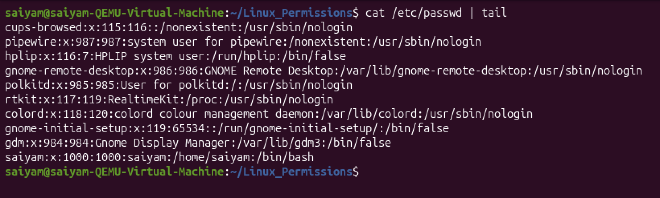
Figure 24: The existing user accounts were viewed by displaying the contents of the /etc/passwd file and checking the last entries using the tail command.

Step 2 – Created a New Group
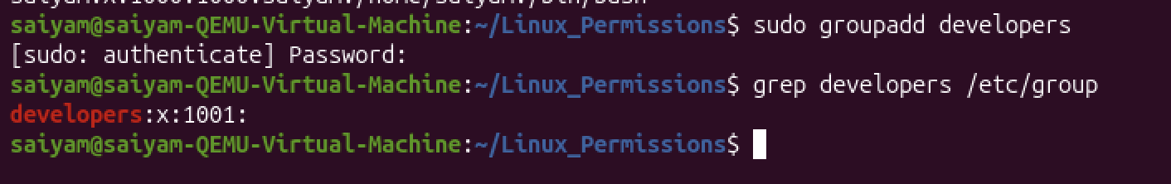
Figure 25: A new group named developers was created using the groupadd command. The group was verified successfully using grep.

Step 3 – Created a New User
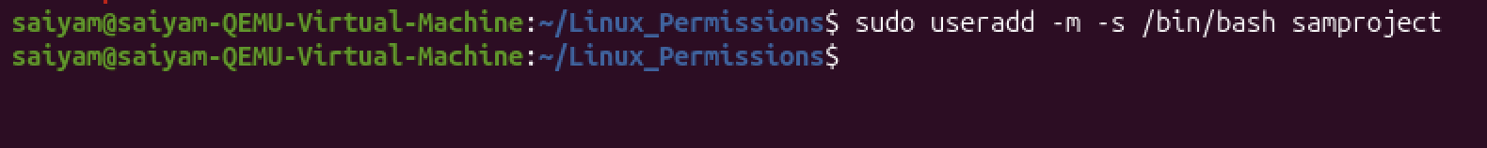
Figure 26: A new user named samproject was created with a home directory and Bash as the default login shell.

Step 4 – Assigned Password
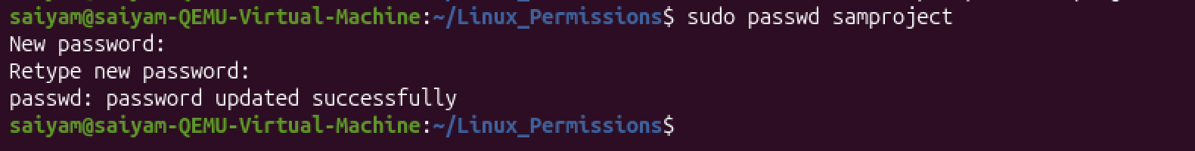
Figure 27: A secure password was assigned to the newly created user using the passwd command.

Step 5 – Verified User Information
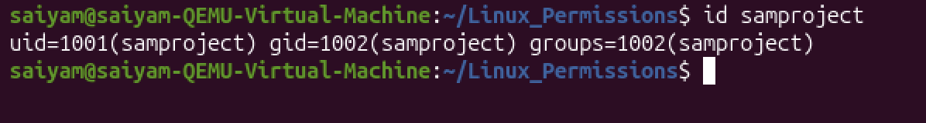
Figure 28: The UID, GID, and default group information of the user were verified using the id command.

Step 6 – Added User to Developers Group
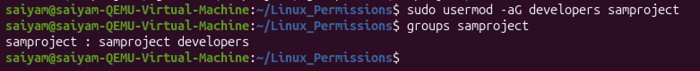
Figure 29: The user was added to the developers group using the usermod command. Group membership was then verified using groups.

Step 7 – Verified Home Directory
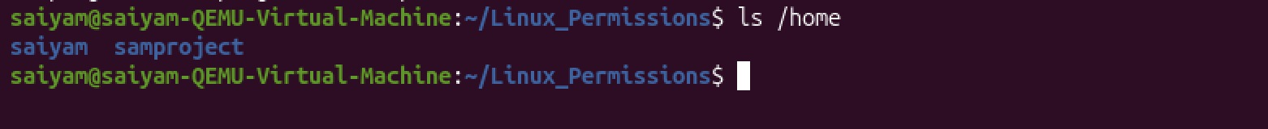
Figure 30: The /home directory was checked to confirm that the home directory of the newly created user was successfully created.

Step 8 – Logged in as New User
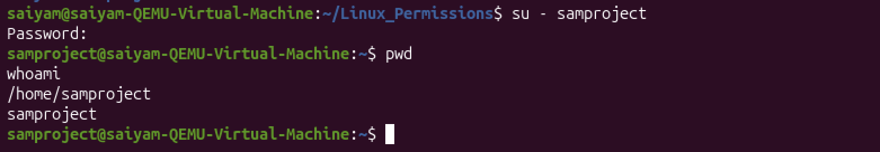
Figure 31: The newly created user account was accessed using the su command. The current working directory and logged-in username were verified using pwd and whoami.

Step 9 – Returned to Original User
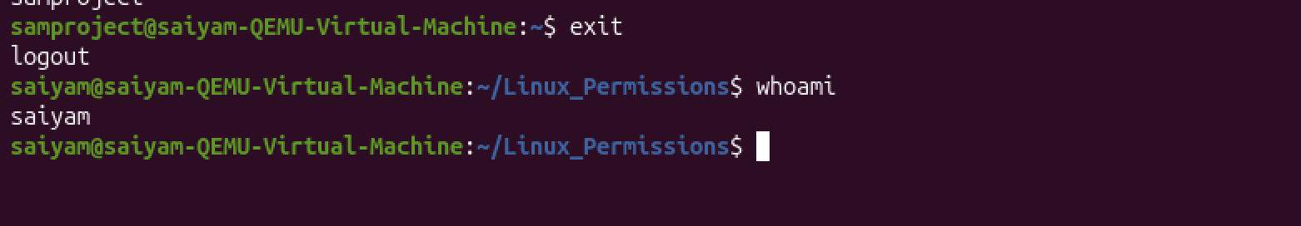
Figure 32: The session of the newly created user was closed using the exit command. The administrator account was verified using whoami.

Step 10 – Final Verification
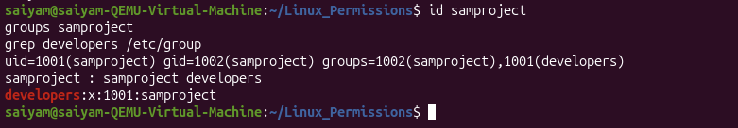
Figure 33: The user details, group membership, and developers group entry were verified again to confirm successful completion of all tasks.

Key Concepts Learned
During this practical session, I learned the fundamentals of Linux user and group management, including the purpose of Linux user accounts and groups in controlling system access. I gained an understanding of User IDs (UIDs), Group IDs (GIDs), home directories, and login shells, as well as the role of password authentication in securing user accounts. I also explored user account management, group membership management, and practised switching between user accounts using the su command, which helped me understand how user privileges and permissions are managed in a Linux environment.

Skills Demonstrated
During this practical session, I demonstrated the ability to create Linux users and groups, assign passwords securely, and manage group memberships effectively. I practised verifying user information, switching between user accounts using the appropriate commands, and checking users' home directories. Additionally, I performed various Linux user administration tasks, gaining practical experience in managing user accounts and maintaining proper access control within the Linux operating system.

Outcome
Successfully completed Linux User and Group Management by creating a new group, adding a new user, assigning a password, modifying group memberships, verifying user details, and testing user login. This phase provided practical experience with essential Linux administration tasks used by system administrators, cloud engineers, and DevOps professionals.

PHASE 4 - PROCESS MANAGEMENT

Objective
The objective of this phase was to understand how Linux manages running processes. This phase focused on viewing active processes, monitoring system resource usage, identifying process IDs (PIDs), running processes in the background, bringing them to the foreground, and terminating processes.

Commands Used

ps | Displays currently running processes.
ps -ef | Shows detailed information about all running processes.
top | Displays real-time system and process information.
htop | Interactive process monitoring tool.
sleep | Creates a process that waits for a specified time.
& | Runs a command in the background.
jobs | Displays background jobs.
fg | Brings a background job to the foreground.
bg | Resumes a stopped job in the background.
kill | Terminates a process using its PID.
killall | Terminates all processes with a specified name.
pidof | Finds the Process ID (PID) of a program.
Ctrl + Z | Suspends the currently running process.

Practical Activities Performed

Step 1: Viewed running processes
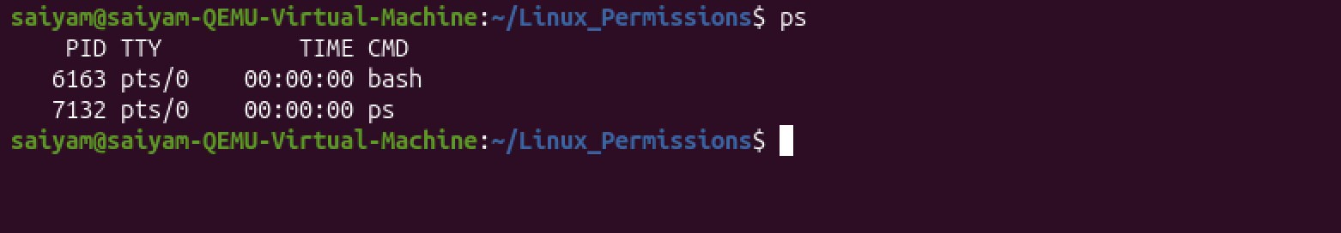
Figure 34: Displayed the currently running processes using the ps command. Observed the Process ID (PID), terminal (TTY), CPU time, and command associated with the active processes.

Step 2: Displayed detailed process information
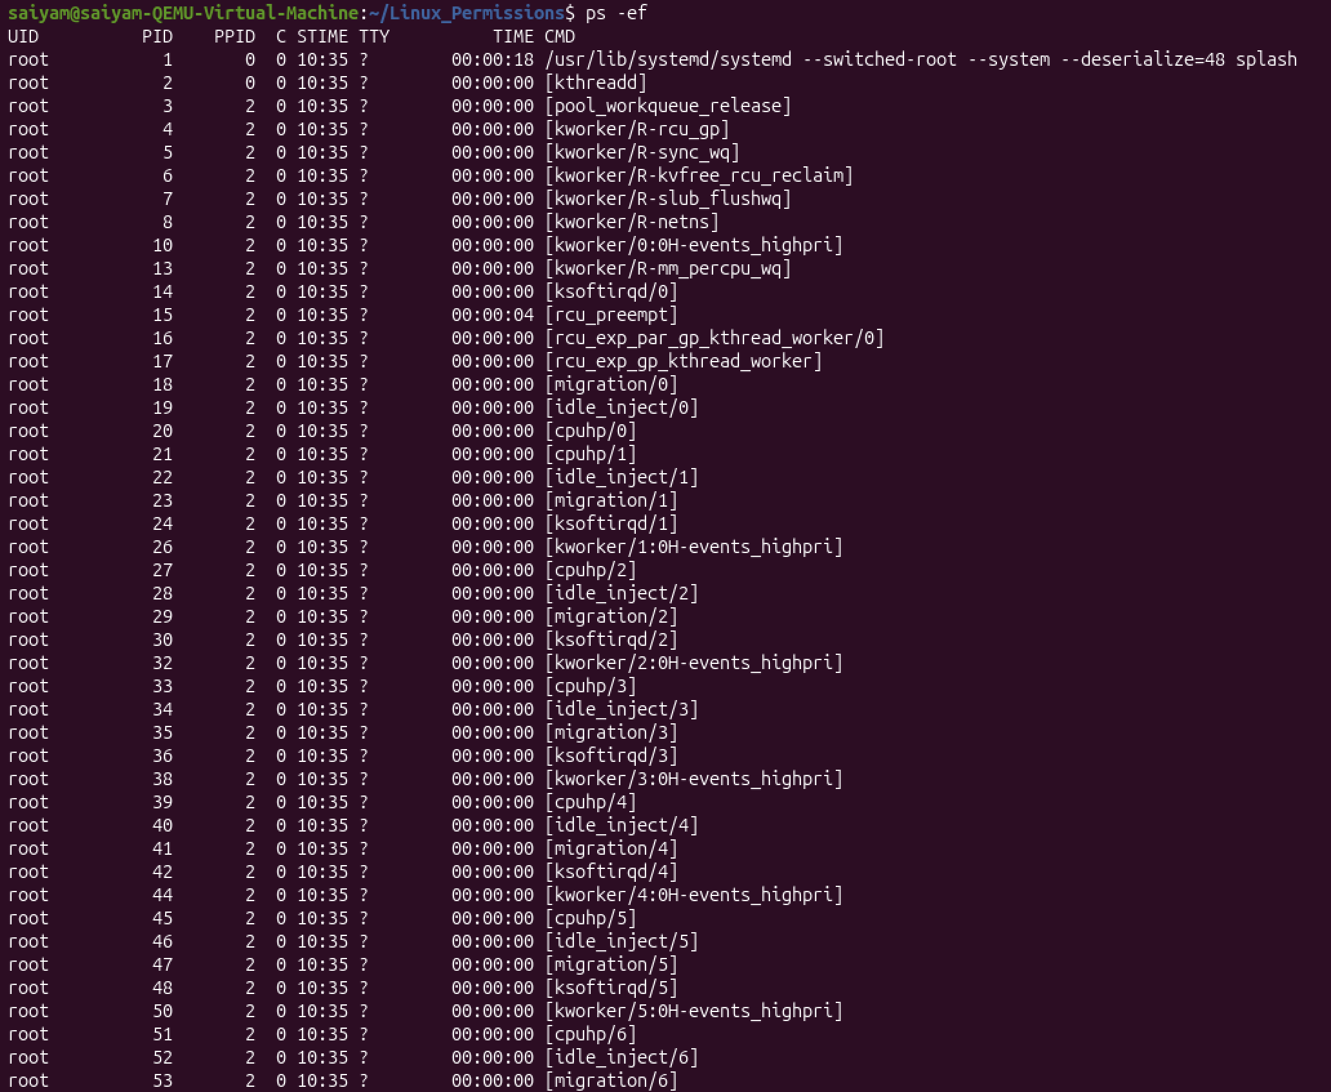
Figure 35: Used the ps -ef command to display all running processes in the Linux system. Verified important process details including User ID (UID), Process ID (PID), Parent Process ID (PPID), CPU time, and command.

Step 3: Monitored system resources
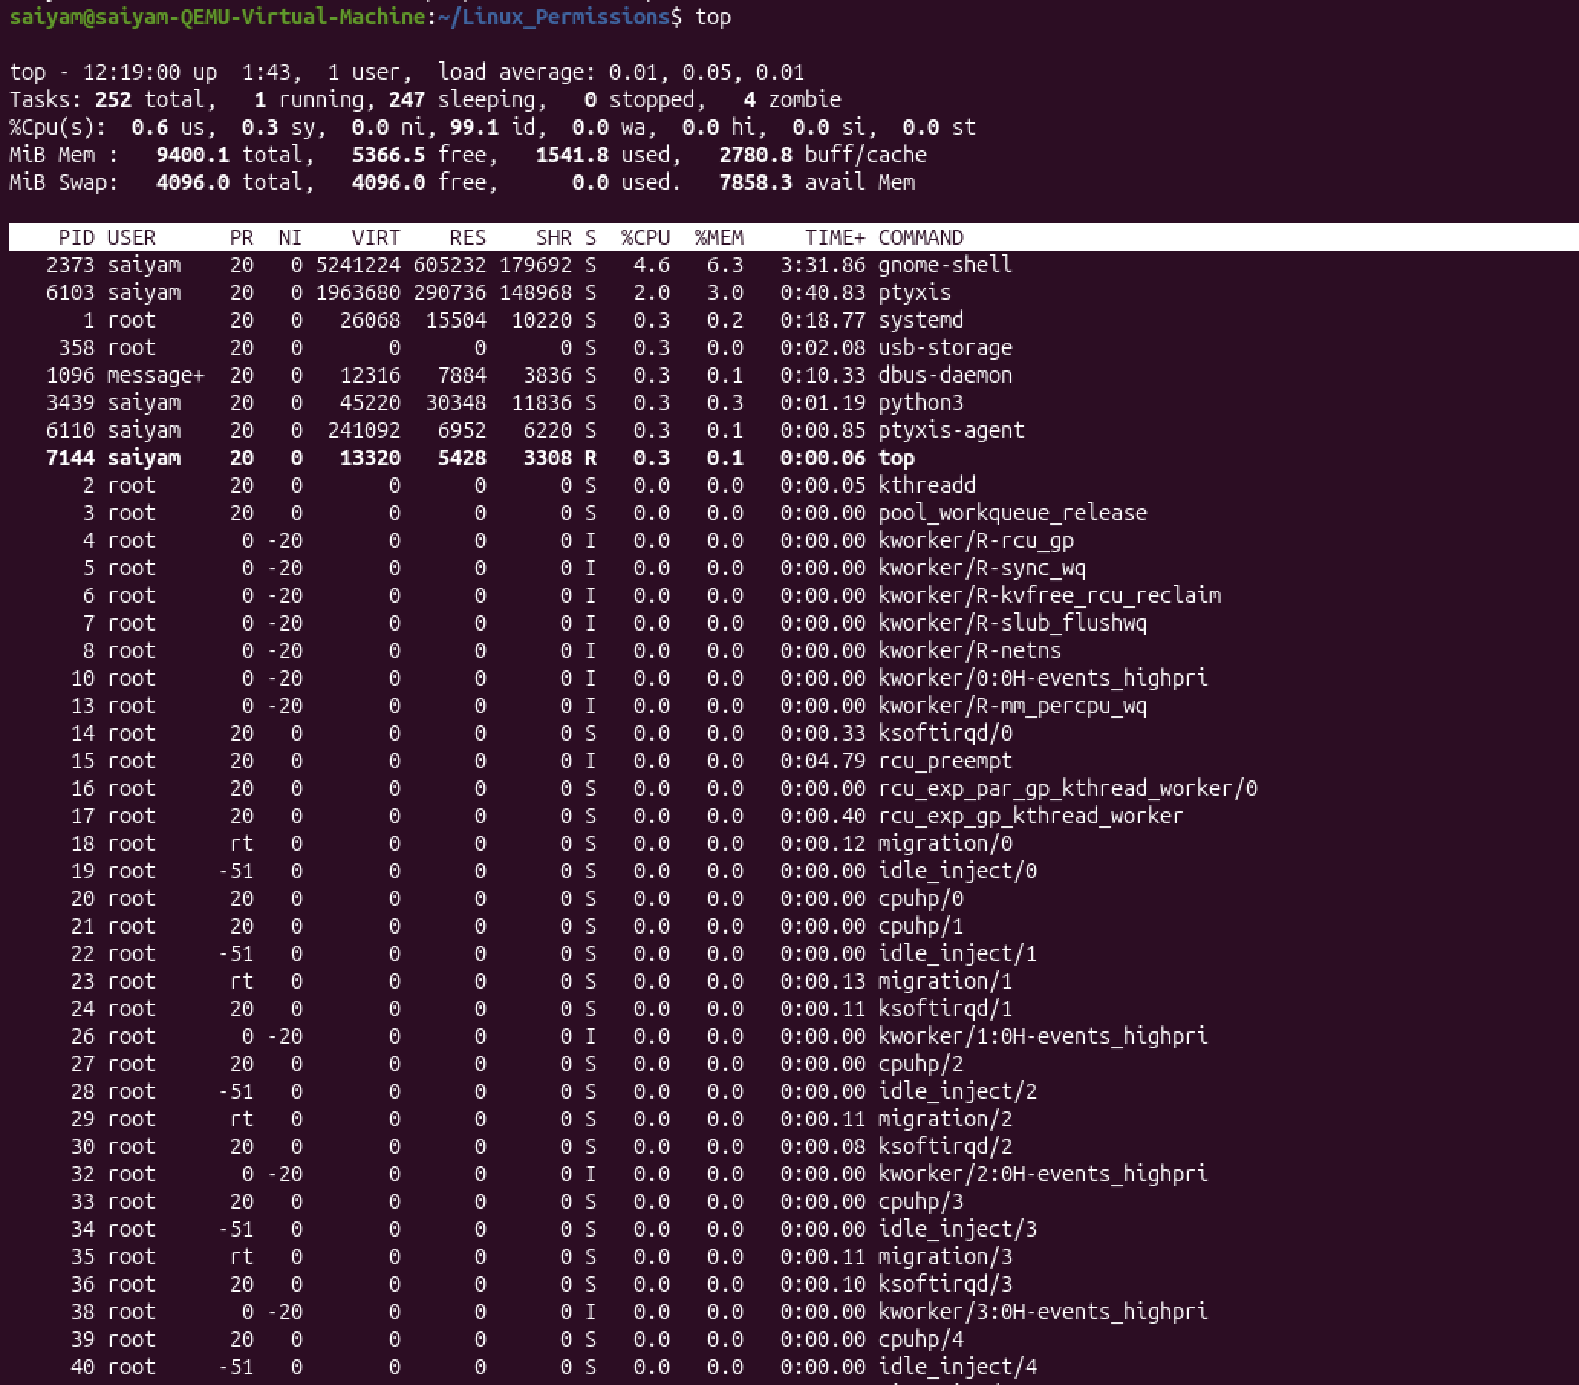
Figure 36: Executed the top command system performance in real time. Observed CPU utilization, memory usage, running tasks, sleeping processes, and overall system load.

Step 4: Created a background process
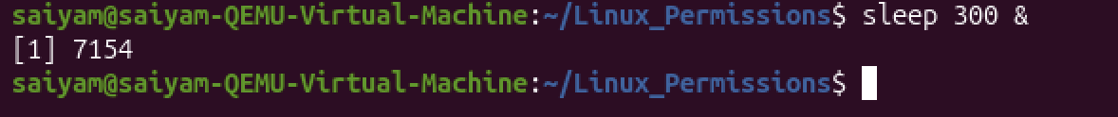
Figure 37: Started a background process using the sleep 300 & command.

Step 5: Verified active background jobs
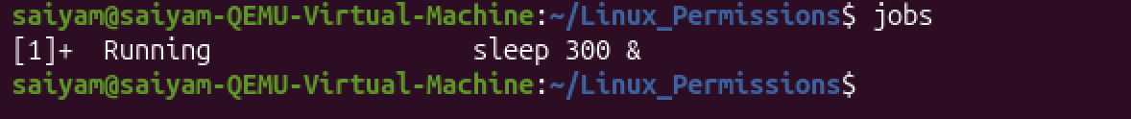
Figure 38: Used the jobs command to display all active background jobs. Confirmed that the sleep process was running successfully in the background.

Step 6: Located the running process
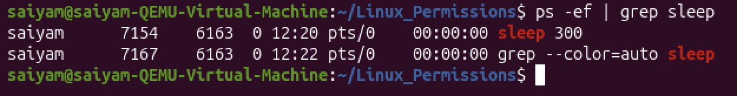
Figure 39: Executed the ps -ef | grep sleep command to search for the running sleep process. Identified the Process ID (PID) of the background process.

Step 7: Attempted to terminate the process
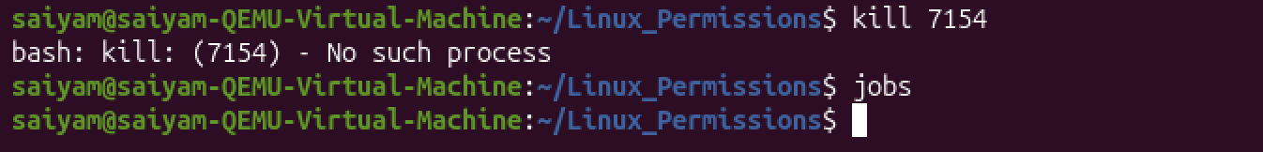
Figure 40: Used the kill command with the Process ID to terminate the running process. Observed that the process had already completed, resulting in the message "No such process."

Step 8: Confirmed process termination
Figure 41: Executed the jobs command again. Verified that no background jobs were running after the process completed.

Step 9: Checked the default nice value
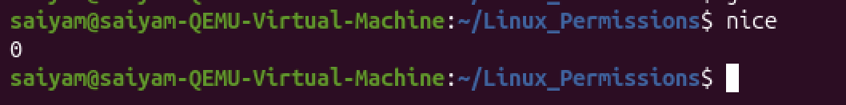
Figure 42: Used the nice command to display the default process priority. Verified that the default Nice value was 0.

Step 10: Started a process with a custom priority
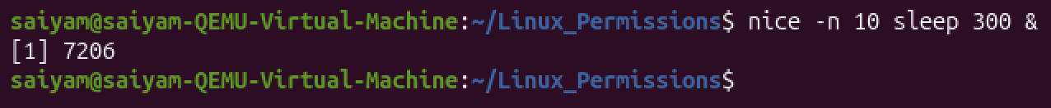
Figure 43: Executed the nice -n 10 sleep 300 & command to create a background process with a Nice value of 10. Assigned a lower CPU scheduling priority to the process.

Step 11: Verified the assigned nice value
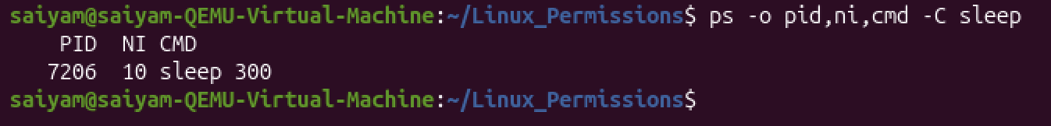
Figure 44: Used the ps -o pid, ni, cmd -C sleep command to verify the priority of the running process. Confirmed that the process was running with a Nice value of 10.

Step 11: Terminated all running sleep processes
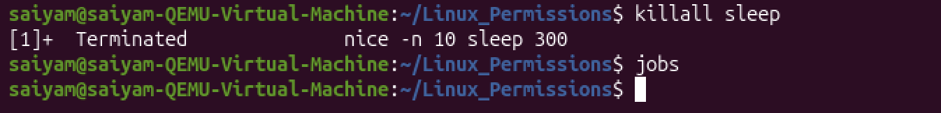
Figure 45: Executed the killall sleep command to terminate all active sleep processes. Verified using the jobs command that no background jobs remained.

Key Concepts Learned
During this practical session, I gained an understanding of Linux process management, including the concept of processes, Process IDs (PIDs), and the relationship between parent and child processes. I learned the difference between foreground and background processes and explored job control techniques for managing running tasks. Additionally, I practised monitoring system processes, terminating processes when required, and observing CPU and memory utilisation to better understand system performance and resource management in Linux.

Skills Demonstrated
During this practical session, I demonstrated the ability to view running processes and monitor overall system performance using Linux process management tools. I practised creating background jobs, managing both foreground and background processes, and suspending and resuming processes as needed. I also learned how to terminate unwanted processes safely and developed a clear understanding of the Linux process lifecycle, including how processes are created, executed, managed, and terminated within the operating system.

Outcome
Successfully performed Linux Process Management by monitoring running processes, creating background jobs, switching between foreground and background execution, identifying process IDs, and terminating processes. This phase provided practical experience with essential Linux process management techniques used by Linux administrators, DevOps engineers, and cybersecurity professionals.

